C
CN LAB

PROJECT TITLE

:
BANK NETWORKING SYSTEM

-

-

-

-

-
134241
-

Page
2

of
16

Table of Contents

1.

Abstract

................................
................................
................................
.........

3

2
.
Introduction

................................
................................
................................
...

3

3
.

Literature Review

................................
................................
...........................

3

4
.

Components and Tools Description.

................................
...............................

3

5
.

Block Diagram
/Flow Chart

................................
................................
..............

3

6
.

Methodology

................................
................................
................................
.

3

7
.

Results an
d Discussions

................................
................................
..................

4

8
.

Conclusion and Future Work

................................
................................
..........

4

9
.

Project Summary

................................
................................
...........................

5

10.

Project Pictures

................................
................................
..............................

5

11
.

References

................................
................................
................................
.....

6

ABSTRACT:
A company in US that deals with banking and insurance want to expand its services across the African Continent. A company has secured a four story building on which they want to setup there network

INTRODUCTION:

- There are four floors in the building.
- Every floor have three different departments, and in each department there are multiple PCs and Printers.
- All the departments must be connected to a single server that would provide DHCP and DNS services.
- The security has to implement on all over the network.
- Every department has to be connected with its separate switch
- All four department should be able to communicate with each other through routers. Every floor has its own router.

COMPONENTS AND TOOLS DESCRIPTION

- This project has been made on Cisco Packet Tracer Tools that are being used are:
- Router: 2911
- Switch: 2950 and 3650
- Wires: cross cable, straight cable, serial cable
- PC
- Printer
- Access point
- Servers

BLOCK / FLOW DIAGRAM
Full Topology:
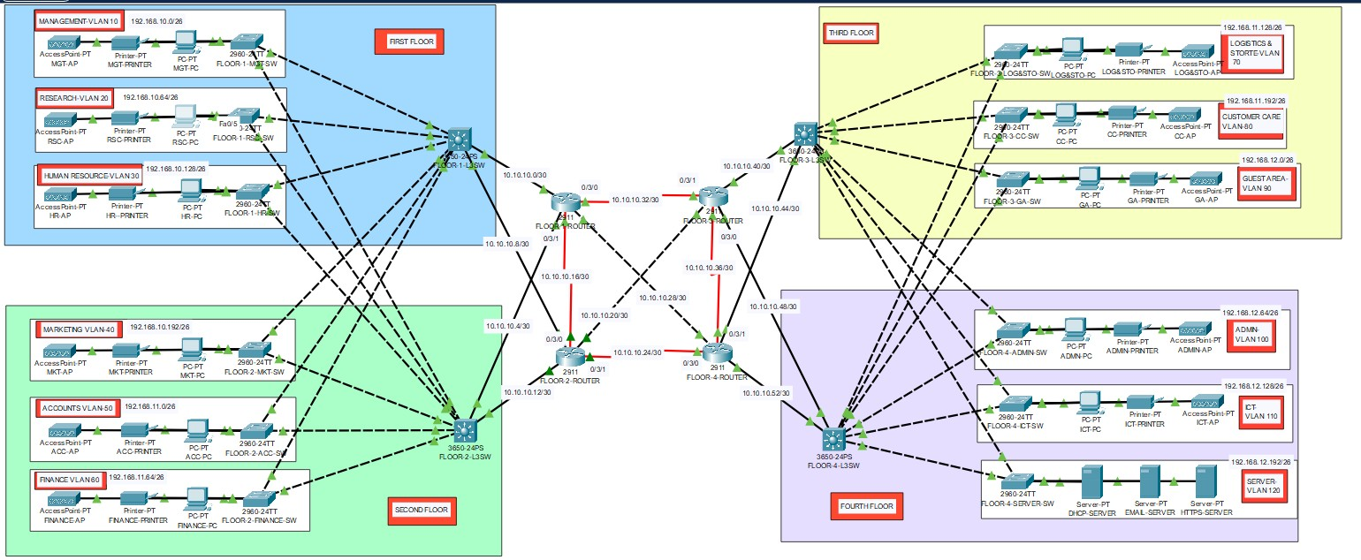
Floor-1:
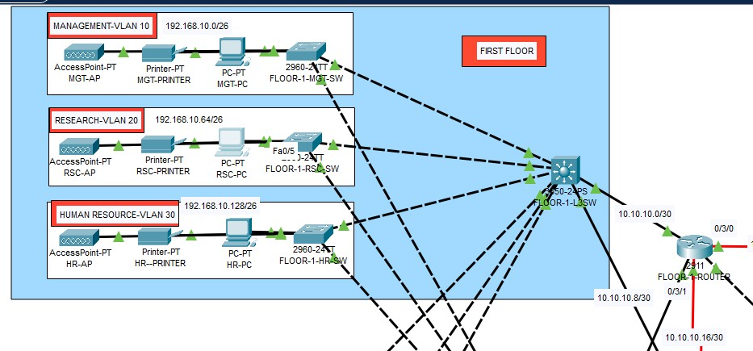
Floor-2:
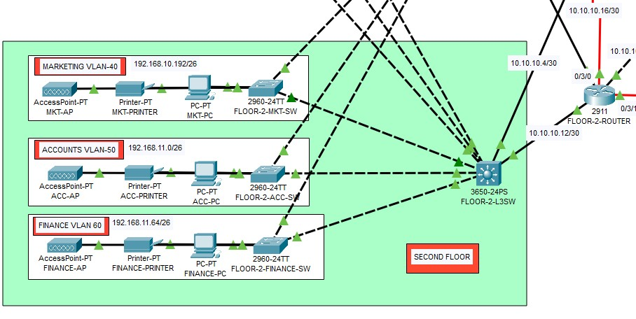
Floor-3:
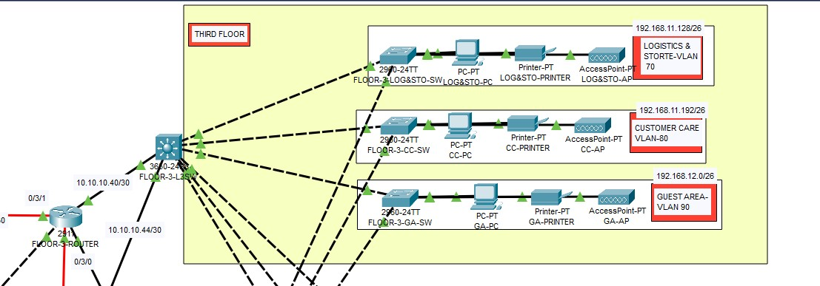
Floor-4
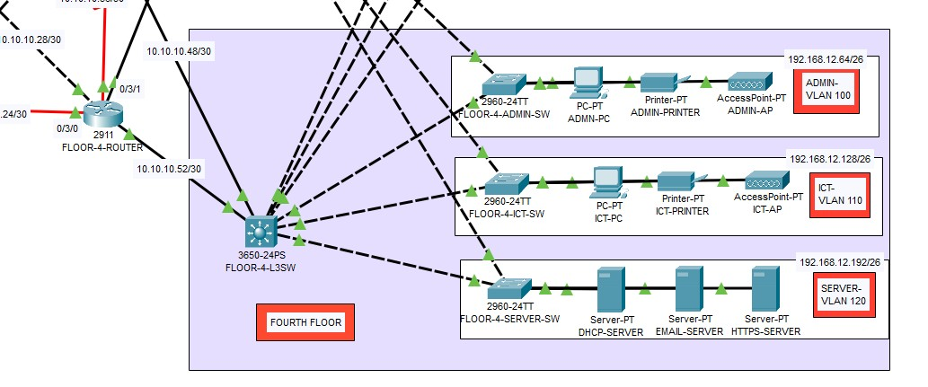
NOTE:
All the department switches are Layer 2 switches
All the floor level switches are Layer 3 switches

METHODOLOGY
- Basic settings to all devices plus SSH on the router and Layer 3 switches
- VLANs assignment plus all access and trunk ports
- Switchport security to all Layer 2 switches
- OSPF on the routers and Layer 3 switches
- Static IP address to server room devices
- DHCP server device configuration
- Inter-VLAN routing on the Layer 3 switches plus IP DHCP helper address
- Wireless network configuration
- Verifying and testing configuration

Basic setting of layer 2 switches:

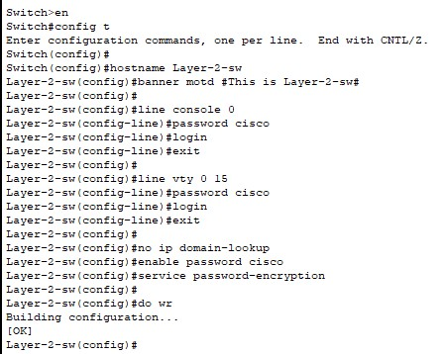

Basic setting of layer 3 switches:

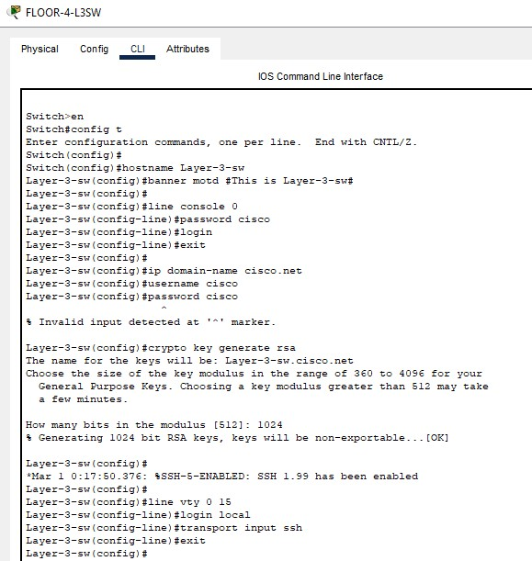

Basic setting of core layer routers:

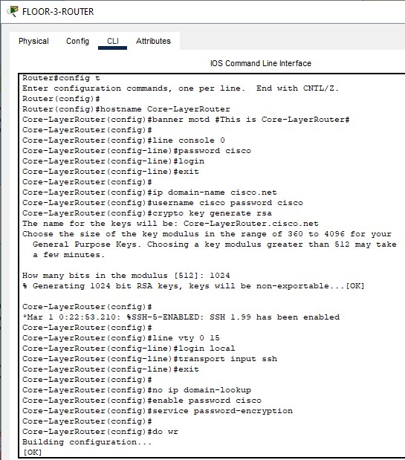

Setting up VLANs and port security on Layer 2 switches:
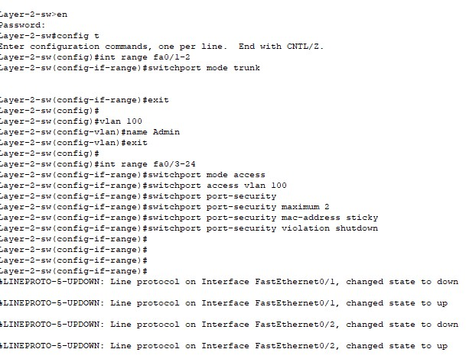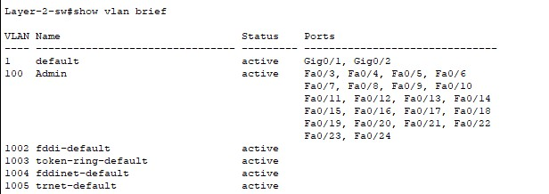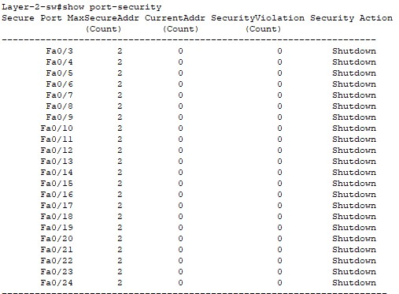

Setting layer 3 switches trunk port:

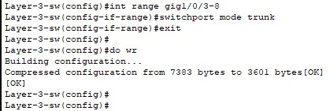

Setting IP addresses for layer 3 switches:

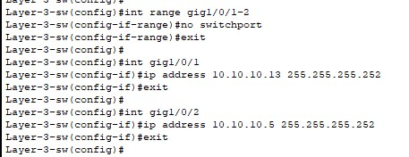

Setting IP addresses for core routers:

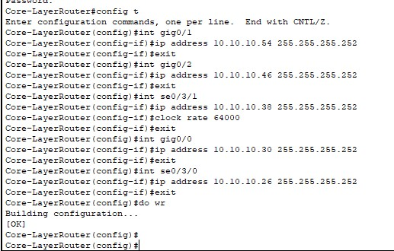
Setting up OSPF on routers:

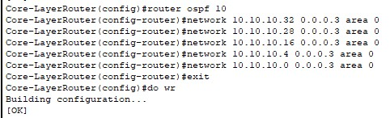

Setting OSPF on layer 3 switches:

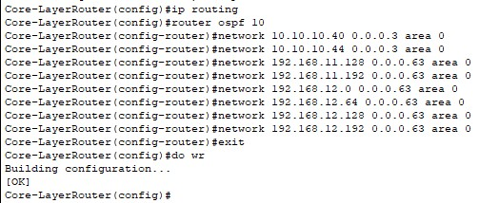

Assigning static IP addresses and gateway to servers in server room
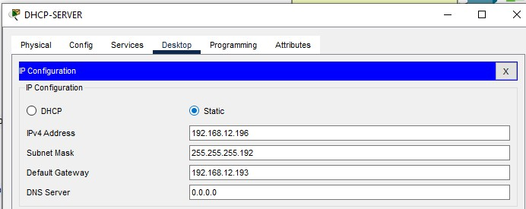

Creating A DHCP server:

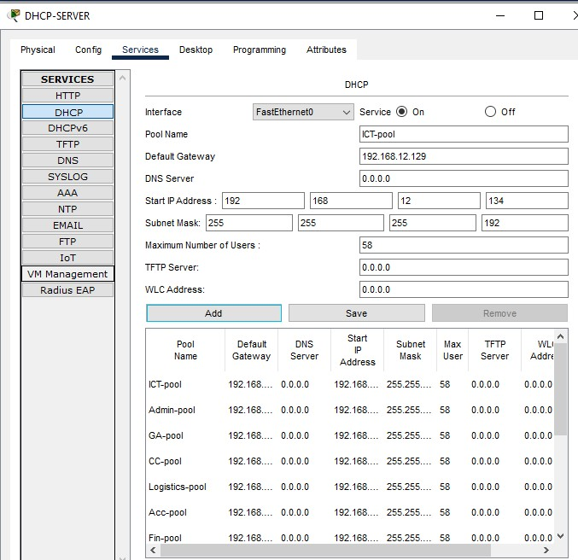

Setting up inter VLAN and helper IP address:

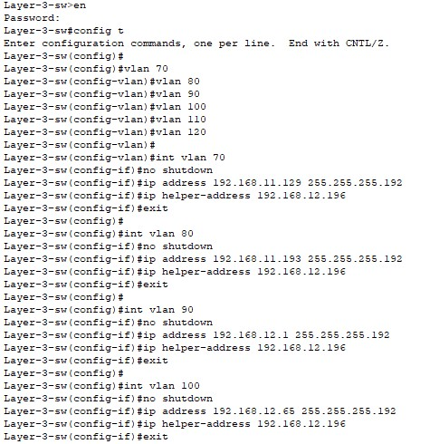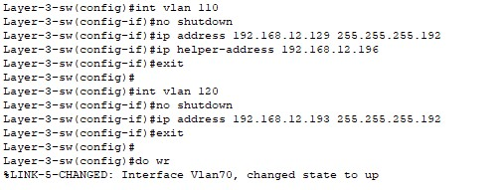

DHCP server successfully working:

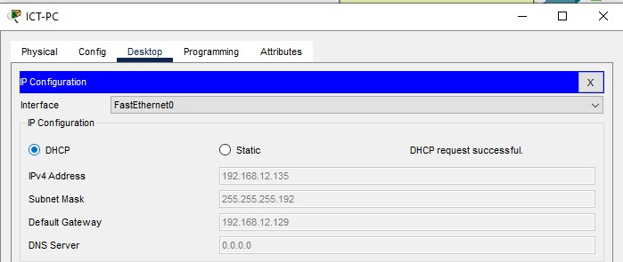

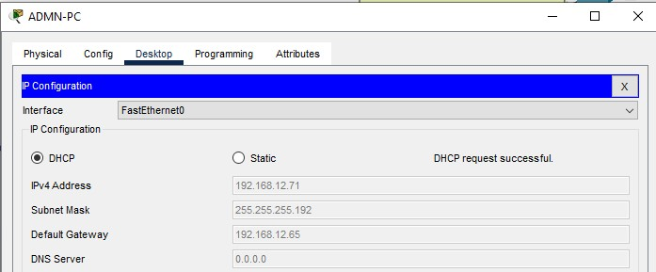

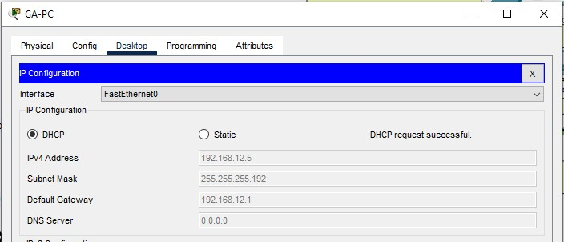
Setting up DNS server:

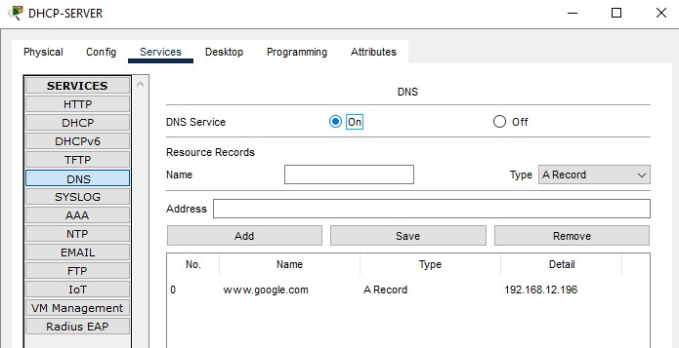

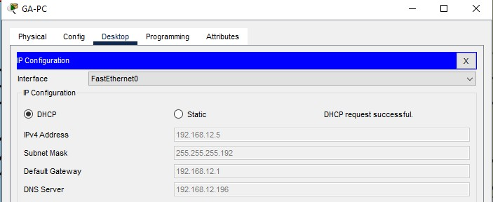

Making one of the Access Point a WIFI:

